## 1.6 Lab Requirements

1. **Complete Tables 1.3, 1.4, and 1.5 (2 points each)**
2. **Write an abstract for this lab and attach with this report. (required to pass course) (10 pts.)**

This lab experiment aims to prove Ohm's law by building a three-loop circuit, where three components are measured and calculated; The Current, Voltage, and Resistance. The values are obtained when the Current is measured with the ammeter, following the principle of resistance equal to the Voltage over the Current; the First Circuit was built; it is essential to highlight that the values are based on a resistor of 1000 ohms.

For Circuit number 2, the resistance was calculated by dividing the sum of the Voltage and the added one over the measured current. In this circuit, the added Voltage and the regular one was already given. Therefore, the measured current and the resistance were the only data recorded. In the last circuit, it was asked to find the Voltage and the current across the resistance of 200 ohms. By having this data recorded, the Power represented with the letter P is calculated by the Voltage across 200 ohms times the current across the same value; it is crucial to pay close attention to the Units; in this case, the Power has to be in Watts.

For the last step, the Current calculated values are obtained by using the quadratic formula, where I calculated works as the Independent value (x) equal to 0.

On the last note, the lab was successful; everything was built with everyone's help, and the data got recorded thoroughly.

Formula circuit 1:

**R= Vs / I**

Formula Circuit 2:

**R= (Vs+V)/ I**

Formula Circuit 3:

**R*I2 – Vs * I + P**

1. **Show hand calculations for all three tables. Insert after this page. (2 points each)**
2. **Insert both plots after this page. (Don’t forget axis labels and title!)(2 points each)**
3. **Answer the following questions:**
4. ***To what component of circuit, one does the slope of plot one correspond? (1 point)***

The resistance

1. ***To what component of circuit two does the y-intercept of plot two correspond? (2 points)***

The Voltage Vs, that were already given.

R= VS/I + V+I

R-VS/I= V/I

V= R*I- VS

***c)  Refer to circuits one and two for the following questions:***

1. ***For circuits one and two, the calculated R should be relatively close to what value? (1 point)***

1000 ohms

1. ***By how much do these values differ from the theoretical resistance as a percentage (calculate for the maximum voltage case of circuits #1 and #2)? Show work. (Hint: Use percent-error equation)  
   (2 points)***

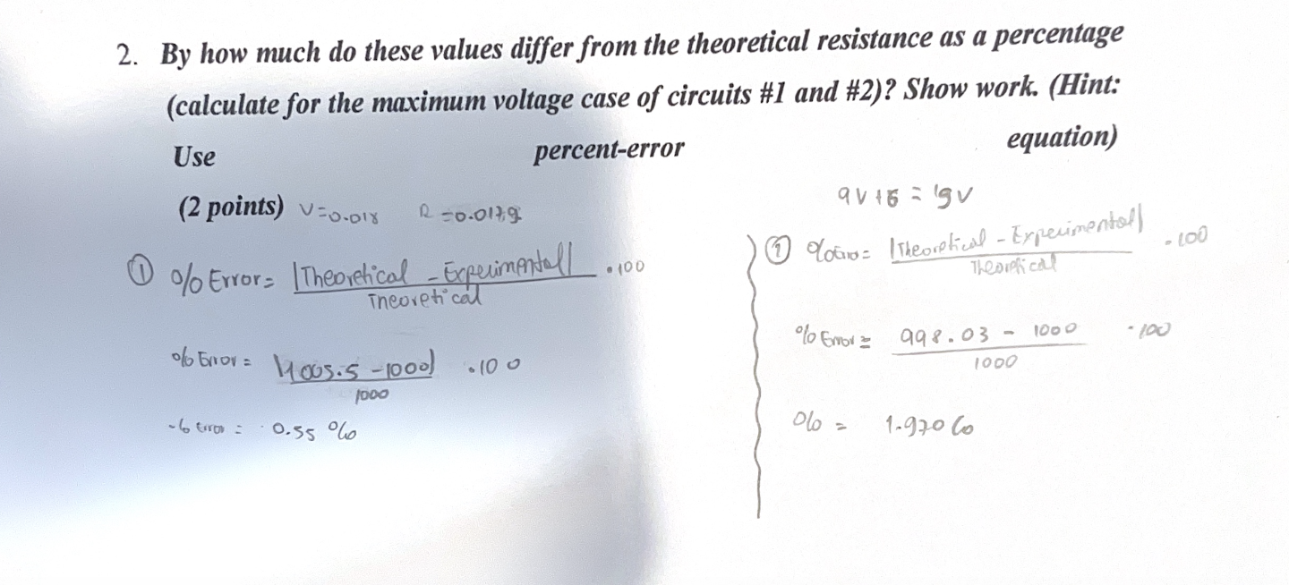

1. ***Is this within the tolerance of the resistor? (1 point)***

Yes it does.

1. ***How do the values for the measured current and calculated current from circuit three compare? What are some reasons for this? (2 points)***

The values are just some units apart, therefore the error percentage, it means that are closer to 1000 ohms, which verifies our answer.